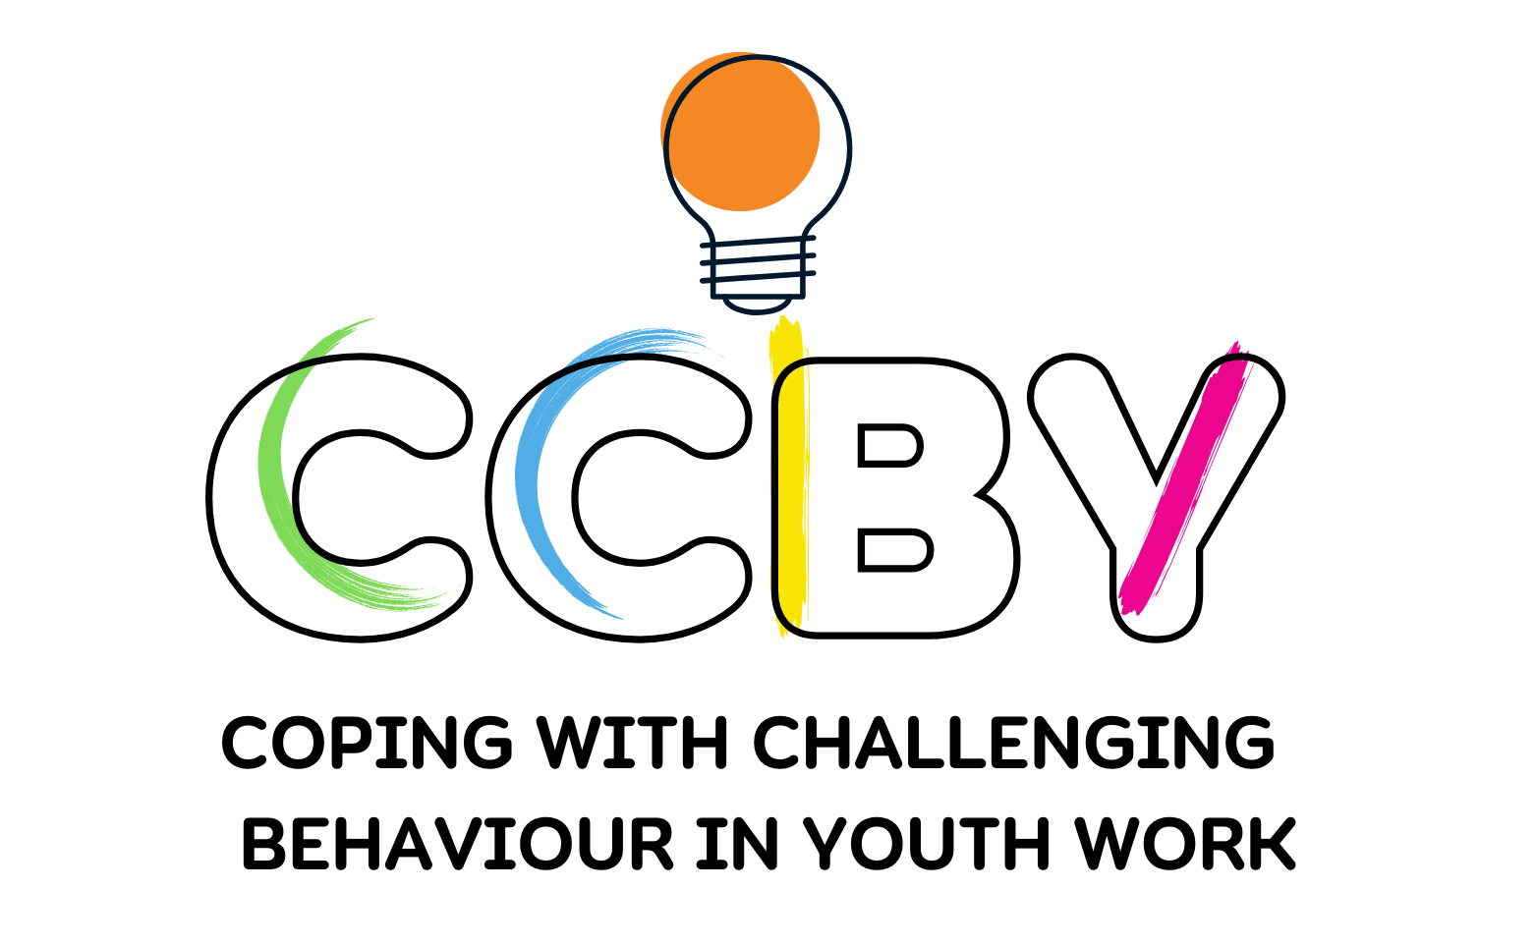 

GRANT AGREEMENT NUMBER: 2023-1-BG01-KA220-YOU-000156252 – Coping with Challenging Behaviour in Youth Work; Programme: Erasmus +

# Guidelines for Youth Worker:

**Who is the Guide for?**

This Guide is written for youth workers, including teachers, social worker or school staff, who will be working with young people. To improve the capacity of youth workers and educators to support young people with challenging behaviors to strengthen their self-esteem, build resilience skills and manage stress in stressful situation.

**What is the purpose of the Guide?**

With the help of this Guide, you will take young people on a journey to explore social and gender norms around violence against children in their school and community, and engage them in activities to build on positive norms to address harmful norms related to violence against children.

**What age groups of young people is the Guide intended for?**

All activities in the guide are applicable for young people age up to 25.

**Children and Young People. What do we mean when we talk about children and young people?**

There are different definitions for a child and a young person, but we chose commonly used definitions that say that a child is anyone 18 years or younger (UNCRC, 1989) and a young person or youth is anyone between the ages of 15-24 (UNDSEA, n.d.).

**United Nations Convention on the Rights of the Child (UNCRC). What is the UNCRC and what are children’s rights?**

Every child around the world has rights. Rights put into words things that you should have or be able to do, so that you can live a healthy, full life and reach your full potential. Children's rights are set out in the [United Nations Convention on the Rights of the Child](https://www.unicef.org/sop/convention-rights-child-child-friendly-version), an internationally recognized document that lays the foundation for children's rights in almost every country around the world. Many of the concepts and terms used in this document were drawn from the rights enshrined in the UNCRC, including the rights to protection and participation.

**Challenging behavior. What does challenging behavior mean?**

‘Behaviour can be described as challenging when it is of such an intensity, frequency, or duration as to threaten the quality of life and/or the physical safety of the individual or others and it is likely to lead to responses that are restrictive, aversive or result in exclusion.’

**Introduction**

Welcome to the 'Me As a Hero' web-platform, where we empower young minds to become the authors of their own narratives. With the assistance of the youth worker the student constructs a chronological narrative of his/her life story with a focus on the traumatic experiences. Fragmented reports of the traumatic experiences will be transformed into a coherent narrative. As a youth worker, your role is crucial in guiding participants through this transformative journey. With your guidance, the narrator can have corrective relationship experiences, empathise with their own younger self and learn self-compassion and self-nurturing. Working through the biography highlights the recognition and meaning of inter-related emotional networks from experiences, facilitating integration and understanding of schemas and behavioural patterns that evolved during development. Here are some guidelines to ensure a positive and supportive experience:

1. **Remind youth to find a Safe Space to fill in the form:**
   * The youngsters should foster an an environment where they feel comfortable sharing their thoughts and stories.
   * Emphasize confidentiality and assure them that their stories are respected and protected.
2. **Explain the Purpose:**
   * Clearly articulate the purpose of the 'Me As a Hero' tool – to explore personal narratives and promote positive change.
   * Highlight the potential for personal growth, resilience, and improved mental well-being.
3. **Provide Context:**
   * Share a brief overview of narrative therapy and how it contributes to mental health.
   * Explain the concept of 'Me As a Hero' – a journey of self-discovery and empowerment through storytelling.

The therapy builds on the theory of the representation of traumatic memories. It is thought to contextualize the particular associative elements of the fear network, the sensory, affective and cognitive memories of trauma to understand and process the memory of a traumatic event in the course of the particular life of a client. Therefore, in narrative therapy, the patient, with the assistance of the therapist, constructs a chronological narrative of his life story with a focus on the traumatic experiences. Fragmented reports of the traumatic experiences will be transformed into a coherent narrative. Empathic understanding, active listening, congruency and unconditional positive regard are key components of the therapist’s behavior. For traumatic stress experiences the therapist asks in detail for emotions, cognitions, sensory information, physiological responses and probes for respective observations. The patient is encouraged to relive these emotions while narrating without losing their connection to the “here and now”: using permanent reminders that the feelings and physiological responses result from memories, the therapist links the experiences to episodic facts, i.e., time and place. In this way reprocessing, meaning-making and integration is facilitated.

The method of narrating the entire life story does not require the clients to select a single traumatic event from their trauma history. The therapy allows reflection on the person’s entire life as a whole, fostering a sense of personal identity. Working through the biography highlights the recognition and meaning of interrelated emotional networks from experiences, facilitating integration and an understanding of schemas and behavioral patterns that evolved during development.

1. **Listen and Speak with Young People**

* Actively Listen: Take time and listen carefully to young people and their stories. Make sure you are fully listening and not just waiting to speak. Listen as much to what young people say, as to what they do not say. There is much information in their silence and body language.
* Treat young people with respect: Sit with young people while they are doing activities, ask questions and learn how they see things, and what roles they play in their families/communities.
* Pay attention to body language: Watch body language (e.g. fidgeting, being noisy or aggressive or being very shy or quiet). Look for clues about how young people are feeling during activities.
* Reflect on your own attitudes: We all have ideas of how things are and why they are like that based on our own life experiences and culture. Remember that your own experience will affect your understanding of others’ stories.

1. **Emphasize Self-Expression:**
   * Use a positive approach: Stay positive and energetic.
   * Be a role model: Act in positive ways. Share healthy values that young people can learn from. Guide young people, but do not direct them or assert your opinion.
   * Build relationships: Help young people feel valued and respected. Create spaces of trust by using fun and engaging energizers. Be sensitive and sincere.
   * Be patient and flexible: Things don’t always go as planned!
   * Encourage participants to express themselves authentically. Remind them there's no right or wrong way to tell their story.
   * Stress the value of self-reflection and the opportunity to redefine their narratives.
   * There is no single truth. Instead, you have your own view of reality, and another person has their own view as well.
   * When we attach meaning to something, it has a foundation in social, cultural, and political contexts.
   * You are never the problem. The situation is the problem.
   * You are an expert on your own life.
   * You can become the author or narrator of your own story.
   * When you create your narrative, you have already assigned meaning to events in your life. Your narrative affects how you see yourself and how you live your life.
   * Maximizing your skills and abilities means that you can take control of your life and let go of past trauma.
   * No problem has complete influence over your life. There are moments, relationships, and events that remain pure and uninfluenced by the trauma you went through.
   * The atmosphere should be welcoming, respectful, non-judgmental, and professional.
2. **Highlight the Four Parts:**
   * Introduce the four parts of the tool: Putting Together the Narrative, Externalization, Contribution, and Unique Outcomes.
   * Emphasize that each part plays a unique role in the storytelling process.
3. **Address Caution:**
   * Caution participants about potential emotional reactions during the process.
   * Remind them of available support, such as yourself or mental health professionals, if needed.
4. **Monitor Progress:**
   * Regularly check in with participants to gauge their comfort levels and address any concerns.
   * Encourage open communication and let them know you're there to support them.
5. **Promote Inclusivity:**
   * Emphasize that 'Me As a Hero' is an inclusive space for everyone, regardless of background or experiences.
   * Ensure that participants understand the non-judgmental nature of the platform.
6. **Celebrate Achievements:**
   * Acknowledge and celebrate the courage it takes to engage in this process.
   * Highlight the potential for personal growth and positive changes in their narratives.
7. **Feedback Mechanism:**
   * Establish a feedback mechanism where participants can share their experiences and any suggestions for improvement.